How to assign and approve a Je-S form for submission
This user guide will help you to allocate a Je-S form to your own account so that you can approve the form for submission. This is relevant for Heads of School, Heads of Department and Research Division
Je-S can be accessed from https://je-s.rcuk.ac.uk/JeS2WebLoginSite/Login.aspx

Step 1: Log into your account and select Documents from the left hand side
Click on Unallocated Documents if this is available or Fellowship/Outline/Standard proposal to find the document you wish to assign.
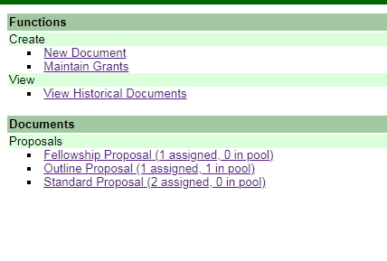

Step 2: Select the relevant document
Select the document you wish to approve from the Unallocated Pool Documents and click Assign.
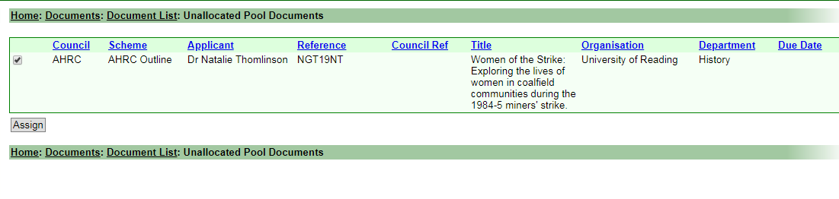

Step 3: Validation and submission of the document
Once the document has been assigned it needs to be validated before submission. Click into the document and hover the mouse over Documents. Select the first option Check Document Validity.
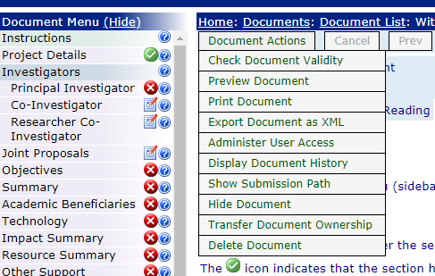

If the validation has been successful you will see the following screen:
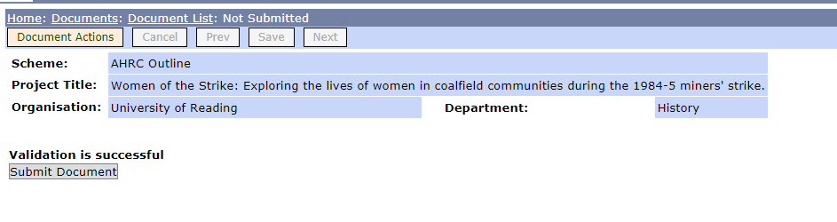
The applicant will already have validated the form to submit it for your approval so this screen should always show that validation is successful.
Click on the Submit button.
The following screen will appear:
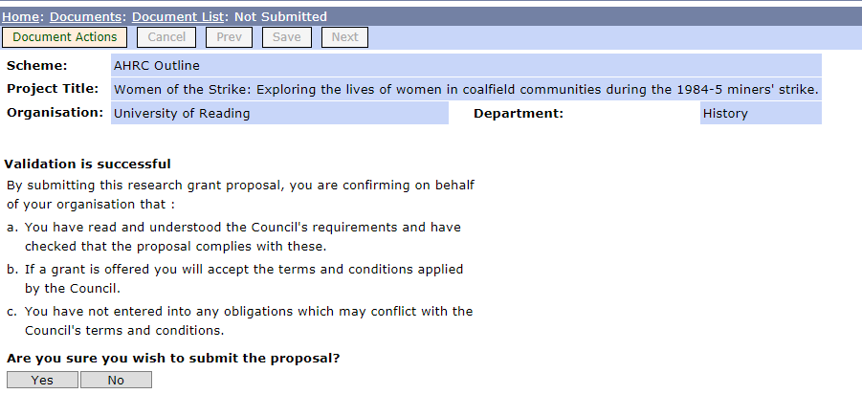
Click on Yes.
This sends the application through to Research and Enterprise Services who perform the final approval. Following the final approval the form is sent through to the relevant Research Council to be evaluated.

