First Aid Equipment Guidance 1st Edition, September 2019
Health & Safety Services

Unit name goes here

The Health and Safety (First Aid) Regulations 1981 does not stipulate a mandatory list of items to be included in a first aid container. The contents of a first aid container depends on the findings of your First Aid Needs Assessment. British Standard BS EN 8599-1:2019 is the reference document for further information.
As a guide where work locations or activities involve low risk hazards a minimum stock of first aid items would be:
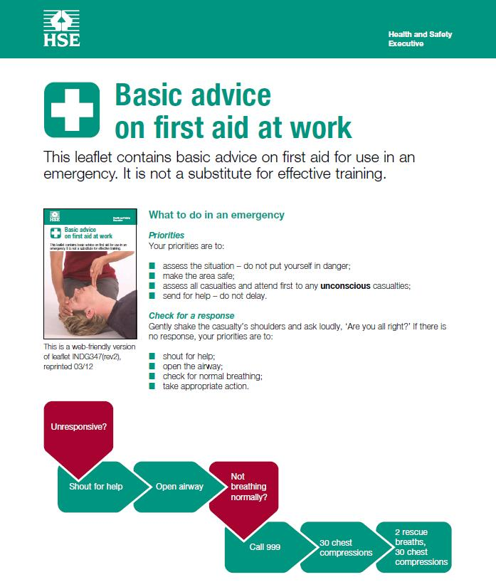 |  | 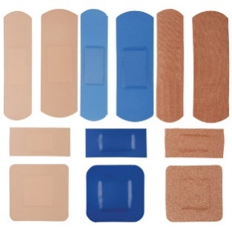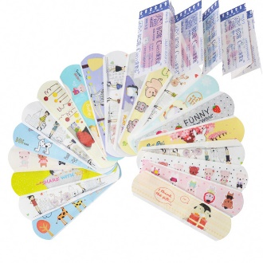
A guidance leaflet on basic first aid |  | Water resistant, sterile, an island design, individually wrapped, min. surface area of 7.5cm2, dressing pad of not less than 20% of the surface area, appropriate to your work environment

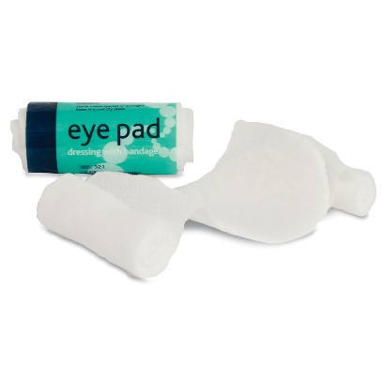 |  | 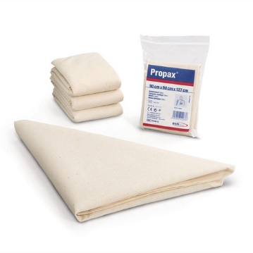
2 sterile eye pads - Conforming bandage: min. 5cm width and min. 1.4 stretched length or elasticated looped bandage, with an oval dressing pad not less than 7cm x 5cm |  | 2 individually wrapped triangular bandages Min. of 20g/m2 non-woven material or cotton, not less than 90cm x 90cm x 127cm
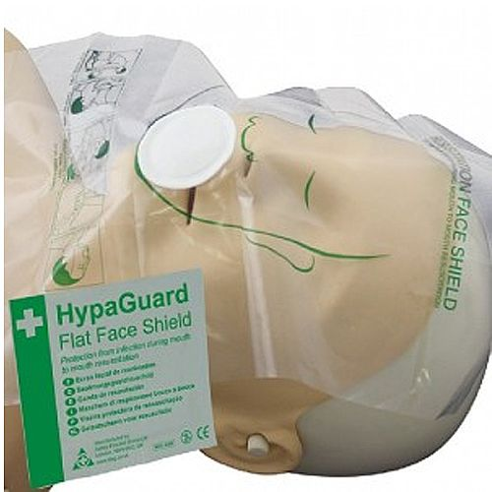 |  | 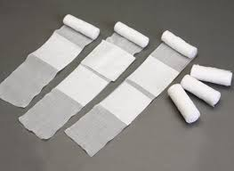
Resuscitation Face Shield including a one way valve |  | 2 large, individually wrapped, conforming dressing: min. 10cm width and min. 2m stretched length, with an absorbent pad: not less than 18cm x 18cm
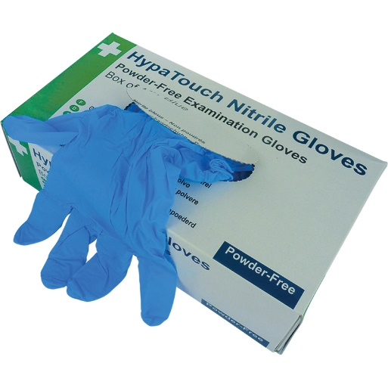 |  | 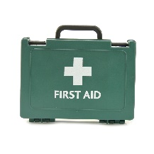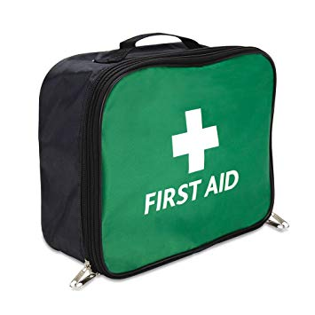  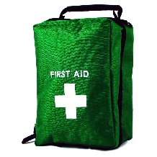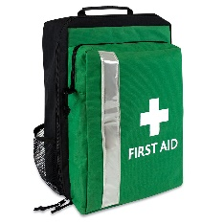
4 pairs of disposable gloves - Conforming to BS EN 455-1 and BS EN 455-2 |  | The container should be clearly identifiable, waterproof, easily transportable and available
Additional items you may wish to consider:-

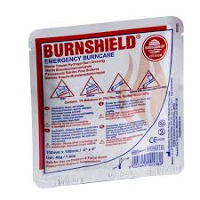 |  | 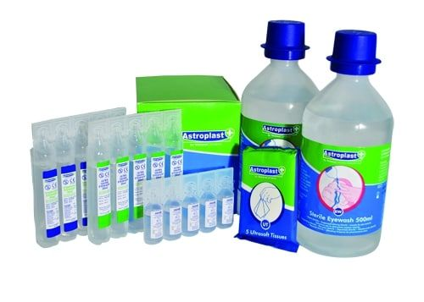
B urns dressings |  | Eye Wash Solution
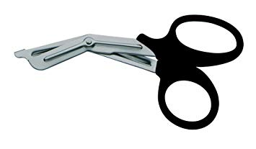
Tough Cut Scissors
The contents of your first aid equipment should be reflective of the types of first aid incidents you would be likely to attend as defined from the findings of the First Aid Needs Assessment.

