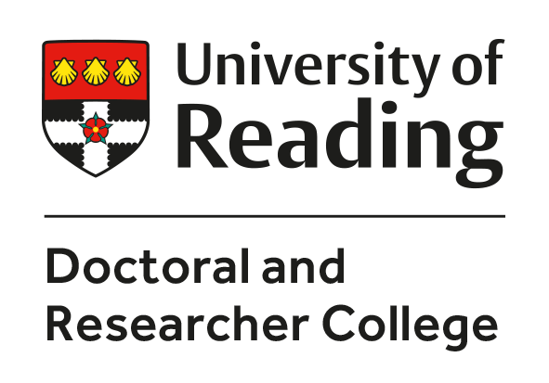
University of Reading Regional Bursary
Guidance on applying

Through the Regional Bursary scheme, The University of Reading seeks to widen access to PhD study. We are committed to having a diverse and inclusive community. The University of Reading’s Equal Opportunities policy applies.
The Regional Bursary is open to applicants who, at the point of application, reside within 25 miles of the University of Reading and have been awarded a place on their chosen PhD programme. Applicants must have made an application for a place on a PhD programme before applying for the Regional Bursary.
Full information, including deadlines for applying and details of eligibility, can be found on our website:
https://www.reading.ac.uk/doctoral-researcher-college/funding/phd-studentships/regional-bursaries

Regional bursaries are awarded to applicants who make a strong case for support across the three awarding criteria:
1. Connection to the region
2. Reasons for choosing the University of Reading
3. How PhD study will be of benefit.
The first criterion is the most important.

Making an application
The application form has four sections: 1. applicant details, 2. case for support, 3. why you need a bursary (optional) and 4. where did you hear about the scheme (optional).

Section 1: Applicant details
This section simply requires applicants to complete ALL boxes with their details. All fields are mandatory.

Section 2: The case for support
This is where applicants are asked to make their case for support by responding to the three questions which are based on the three awarding criteria above:
- What is your connection to the region?
- Why have you chosen the University of Reading?
- How do you hope to benefit from studying for a PhD?

1. Connection to the region
There are many ways in which to demonstrate a strong connection to the region. Residence within 25 miles at the point of application is a prerequisite to apply and does not in itself establish a connection with the region. Long-term residence in the region is one possible strong connection, but other forms of connection can be equally or more noteworthy. Some examples of connections with the region are given below. These are for guidance only and the list is not intended to be exhaustive.
- community engagement, including volunteering
- membership of local associations
- family or other historical connection
- engagement with a particular local group or community
- employment in the region
- hobbies or other activities undertaken in the region.

2. Reasons for choosing the University of Reading
All applicants for a Regional Bursary must have an offer of a place on a PhD programme at the University of Reading. Applicants are invited to discuss what specifically at the University of Reading has drawn them to apply. Examples include:
- the expertise of a particular supervisor
- a particular resource such as a collection or research centre
- a research group or cluster relevant to your research
- links to a particular site or location.

3. Reasons for applying for a PhD and how you expect to benefit from PhD study
The benefits of studying for a PhD are numerous and significant. We seek to support those who will most benefit from PhD Study. Applicants may wish to discuss, for instance:
- the skills and experience they hope to obtain
- the contribution to knowledge which they hope to make
- particular career or other professional goals by which they are motivated.

Section 3: why do you need a bursary
This section is optional.
Here applicants are invited to explain why they need a bursary. This part of the application is NOT used in the selection process, but it helps to inform our future funding provision if we have information on the reasons why people need the assistance of a bursary.

Section 4: How did you hear about the bursary scheme?
This section is optional.
If you are happy to tell us, please indicate how you heard about the scheme. This helps us to understand how effectively we are disseminating information about the Regional Bursary.

The University is committed to having a diverse and inclusive community. It supports the gender equality Athena SWAN Charter and the Race Equality Charter, and champions LGBT+ rights equality.
The University of Reading Equal Opportunities policy applies:
The University of Reading is committed to a policy of equal opportunities and non-discriminatory treatment for all members of its community regardless of age, disability, gender reassignment, marital or civil partner status, pregnancy or maternity, race (to include colour, nationality, ethnic or national origin), religion or belief, sex or sexual orientation.

