Digital Technology Services
Microsoft Teams
Using a headset for Microsoft Teams
Contents
Using a headset with Microsoft Teams 2
Problems? 3
General sound quality issues 6

Using a headset with Microsoft Teams

Windows 10 should automatically detect and install your headset, and you should be able to go straight in to making calls with Teams.
To use the headset with Microsoft Teams:
- Plug the USB cable in to a spare USB port on your desktop, docking station or laptop.
- In Teams, click on your initials or profile picture (top right of Teams screen), then go to Settings – Devices
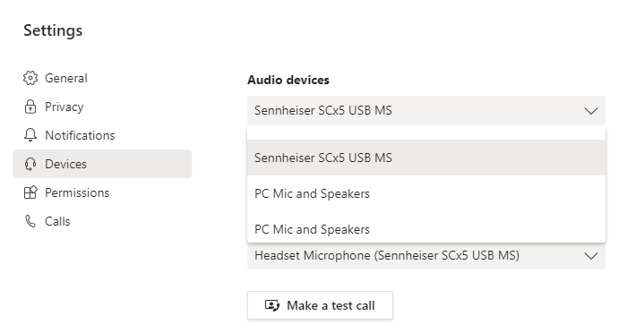
- Sennheiser SCx5 USB MS will now appear in the list of audio devices. Select it to use it with Teams.
- Make a test call to check your audio settings. This is an automated response to check the microphone and speaker, as well as voice quality. You will get a results page to tell you everything is OK.

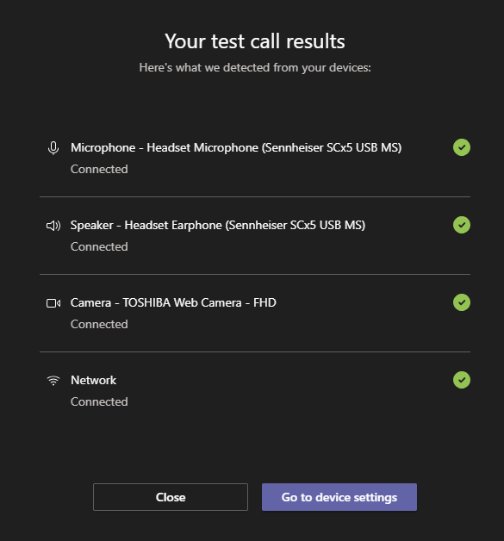
Results page showing everything is working OK.

Problems?
If the headset doesn’t show up, or the test call shows an issue with the Microphone or Speaker, there are a few things you can do before contacting Support.
First of all, try a different USB port – particularly on desktops. For laptops being used with a docking station, plug in to the docking station rather than the laptop.
Secondly, check the physical connections:
Check the connection between the headset cable USB connector and the computer (take it out and plug in again).
Check the connection between the headset cable and the inline controller (take it out and plug in again). Make sure you have pushed the connector all the way in – you should not see any gold and it should not wiggle.

Check the audio settings to see if the headphones show up and are selected:
At the bottom left of your screen, you should see a speaker icon in your taskbar:
Left click the speaker icon. You will get a list of the playback devices associated with your computer. See if the Sennheiser is listed and selected, with a volume above 0.
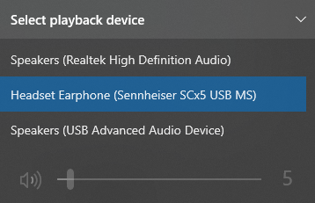
If not listed, we need to check that the headphones are enabled in the system. Right click the speaker icon, and select Sounds
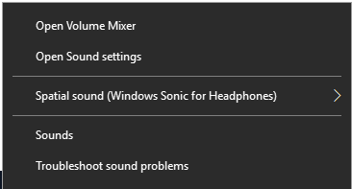
This opens a new window. Select Playback and look for the headphones there. If listed, select Properties and check the usage is enabled.
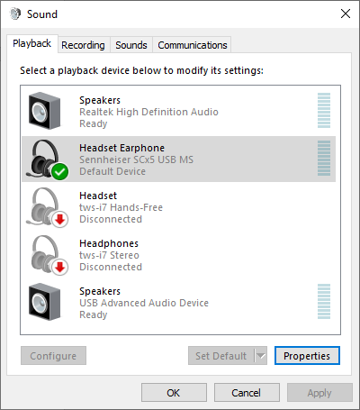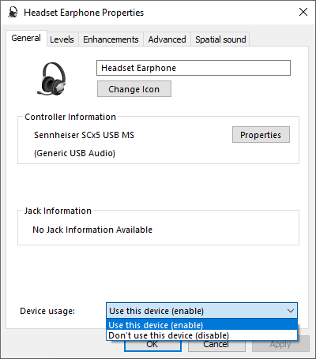

Finally, check the Windows 10 settings. Go to the control panel by Windows key - Settings – Sound, or by typing “Sound settings” in to the search bar. Again, check that the headset appears in the Sound and Input sections. You can test from Manage sound devices
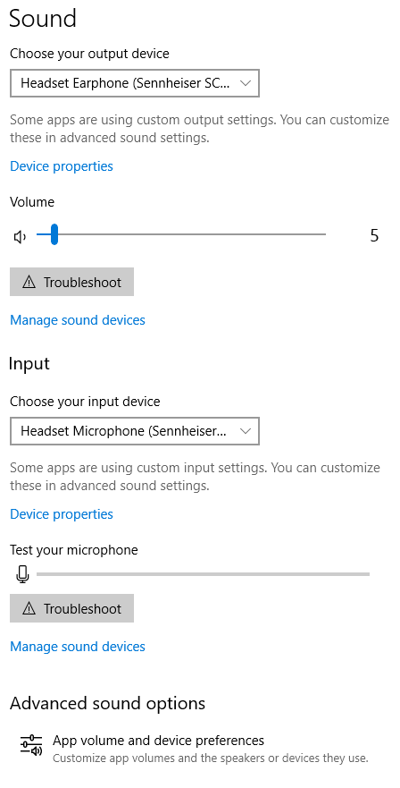

General sound quality issues

What should I do if I only get sound in one side of the headphones or have general sound quality issues?
- Check the physical connections
Check the connection between the headset cable and the computer (take out and plug in again)
Check the connection between the headset cable and the inline controller (take out and plug in again)
Note that a properly connected cable should not wiggle. If the plug wiggles that could indicate a loose connection.
- Check there is nothing in all physical connections and they are clean
Make sure that there is no debris (ie: no dust or lint) in the headphone jack of the audio source that may be inhibiting connectivity and causing sound issues.
If oils from the hands gets builds up on the plug or sweat evaporates on the plug the salts and grime may prevent proper contact from occurring. The connecting jacks can be cleaned using a basic alcohol wipe.
- Is the problem is the headset or the computer?
Try an alternative USB port on your computer or docking station, or with a laptop try with the laptop out of the docking station
Try a different headset (can you borrow someone else’s to test?)
Try your headset in someone else’s computer, or in a mobile (using the 3.5mm jack)
If the problem is the computer, try the Troubleshooting steps above.
If the problem is the headset, ask for a new one (via the IT Self Service Portal TopDesk)

