Setting up your new Microsoft Surface
This guide will help you through the process of setting up your new Microsoft Surface.

Setting up your Microsoft Surface

Help
If you encounter any problems with these instructions, or you have any other issues with your new device, please raise a ticket with the IT Service Desk: https://uor.topdesk.net/

Before you start
Things to note:
- Initial set up will take around 30 minutes.
- An internet connection is required. If you are at home, make sure you know your Wi-Fi key. This is normally found on a sticker on your router.

Plug in the power cable (provided in the box) into the power supply and then into your power socket. The power cable is round and plugs into a port on the side of the device (see photos or we have video how to plug in your new laptop).
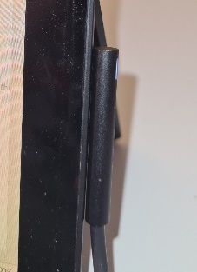
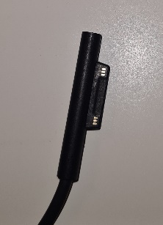

Turning on the device
Turn on the device by pressing the power button.
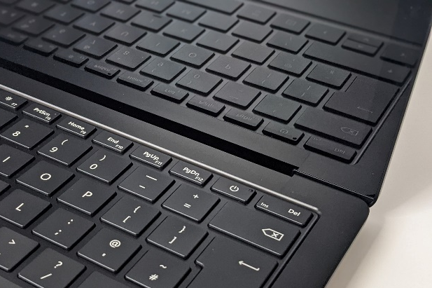
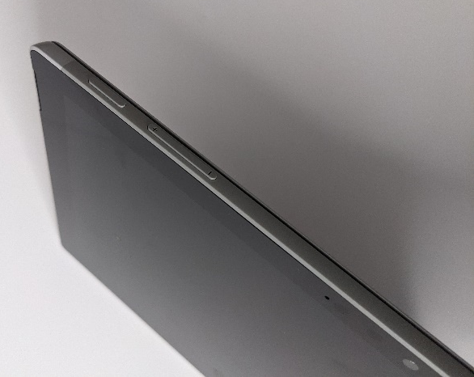
Microsoft Surface Laptop and Surface Go Microsoft Surface Pro 7+
The screen will display the Surface logo for a couple of minutes while it starts up.

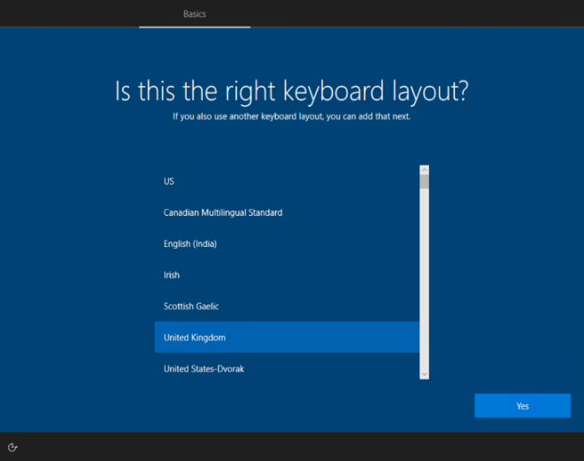
Choose language
Once your Surface has started up, it will display a screen asking you to select a language. Select “English (United Kingdom)” and then click “Yes” in the bottom right hand corner.
If English isn’t your first language, you can choose a different language on this screen.

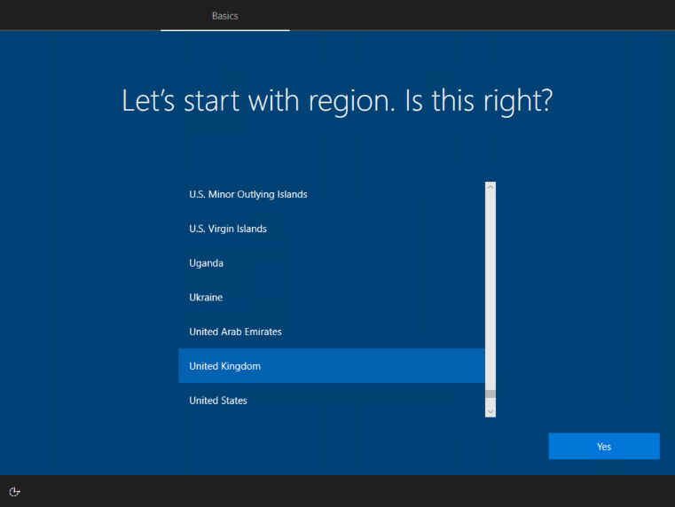
Choose region
On the next screen you will be asked to select a region. Select “United Kingdom” and then click “Yes”.
Important: You should select “United Kingdom” even if you have not chosen English as the language.

Choose keyboard layout
On the next screen you will be asked to select a keyboard layout.
Select “United Kingdom” and then click “Yes” in the bottom right hand corner. You will be given the option for an alternative keyboard layout in the next screen.

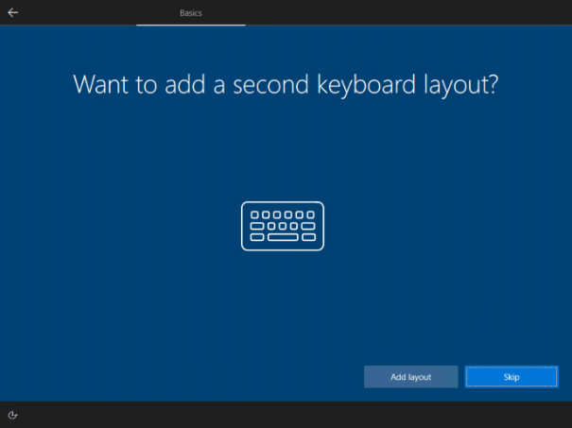
Choose a second keyboard layout (optional)
If you are used to a different keyboard layout (e.g. American) or other characters (e.g. Russian) then you can choose a secondary keyboard here.
If you do not require a secondary keyboard click “Skip” instead of “Yes”.

Choose a Wi-Fi network (internet)
On the next screen you will be asked to connect to a network in order to set up an internet connection. You need an internet connection to set up your new computer – do not attempt set up without being connected. If you are having issues with connecting to Eduroam, please stop set up and raise a call with the IT Service Desk.
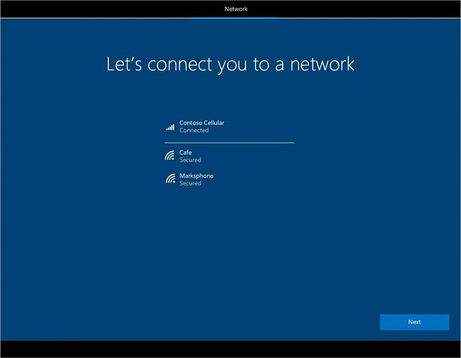
On campus: Click the Wi-Fi network called “eduroam” and then click Connect.
In the “username” box need to enter your University of Reading IT username followed (for example ab123456@reading.ac.uk) and then your password in the “password” box.
At home: If you are using your home Wi-Fi you will need to enter your network key (sticker on your router).

Wired: If you are using an Ethernet (wired) connection you will skip this screen during set up.
Once you are connected to your chosen network, “Connected” will appear. You can then click “Next” to proceed.

Log in to your University of Reading account
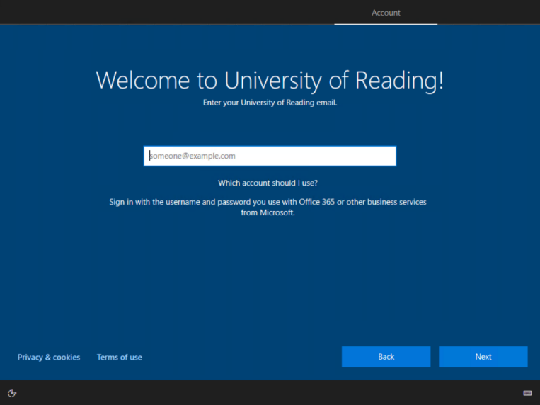
On the next screen you will be presented with the message “Welcome to the University of Reading”.
In the box below, enter your University of Reading IT username followed by “@reading.ac.uk”. For example ab123456@reading.ac.uk.
Then you will be asked to enter your password. Enter your University password and then click “Next”.

You may be prompted to authenticate your login via MultiFactor Authentication (MFA). For information on this, please visit the DTS webpage.

Finish set up
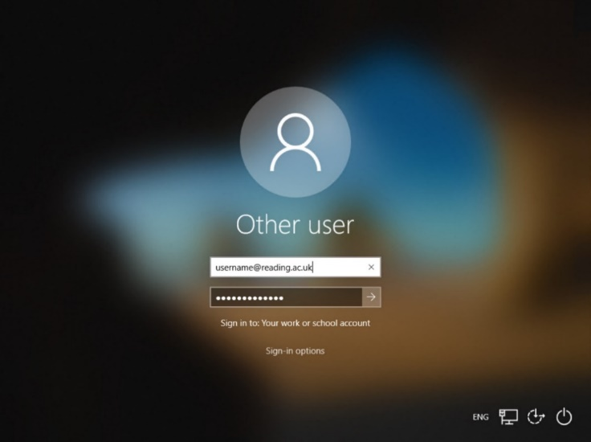
Your new Surface will then go through setup. This could take a while so leave the device alone until you get a logon prompt. With a good Wi-Fi connection, this will take around 30 minutes.

When the device has nearly completed setup, you will be taken to the Windows login screen.
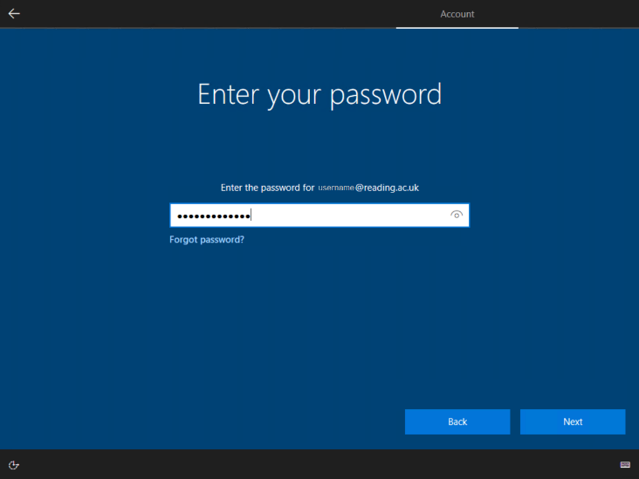
Enter your University of Reading username followed by “@reading.ac.uk”. For example: ab123456@reading.ac.uk.The device will then finish the setup.
When the desktop appears on screen your device is ready for you to use.

Help
Your device will come with Office 365, Pulse Secure, Microsoft Defender (anti-virus), AppsAnywhere/CloudPaging Player and Chrome browser already installed.
If you need access to software that is not available via AppsAnywhere, please log a request via the software request form.

If you encounter any problems with these instructions, or you have any other issues with your new device, please raise a ticket with the IT Service Desk:

IT Self Service Portal | uor.topdesk.net
Email address | dts@reading.ac.uk
Telephone (internal or Teams) | 6262
Telephone (external or mobile) | 0118 378 6262

